Project name: Statistical Machine learning Approaches Team Id:  PNT2022TMID40553

To Liver Disease Prediction

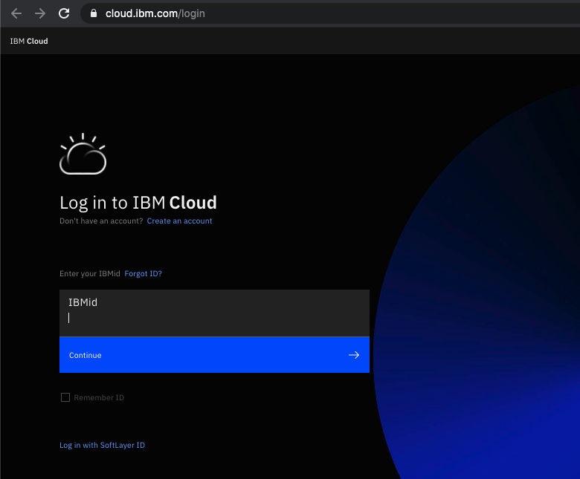

STEP1:Open the IBM Academic initiative URLibm.com/academic in a web browser

STEP2:Click Register Now

STEP3:Enter your Academic Institution,University,College issued email ID

STEP:Select Whether you are a Student or a Faculty Member